

APPLICANT DETAILS FORM
PART 1 – APPLICATION INFORMATION (Filled by Employer)
EP duration to be applied for | (12) Months
Proposed position | (--)
Monthly basic salary in RM / MYR | (--)

PART 2 – APPLICANT’S PERSONAL INFORMATION (Filled by Applicant)
2A: Personal Particulars
Full Name (as on travel document)

–

Current Residential Address

–

Preferred Visa Collection Centre (List attached in email)
–
Marital Status  – | Email Address  – | Mobile Number  –
2B: Particulars of Applicant’s Spouse

Only complete this section if your spouse accompanying you to Malaysia during your employment in Malaysia and would like to apply
for a Dependent Pass (DP).

Spouse’s Name

(--)
Current Residential Address:

(--)

PART 3 – OTHER INFORMATION (Filled by Applicant)
Have you ever: YES / NO
(a) Been refused entry into or deported from any country?
(b) Been convicted in a court of law in any country?
(c) Been prohibited from entering Malaysia?
(d) Entered Malaysia using a passport issued by a different country?
(e) Entered Malaysia using a passport showing another name?
(f) Been a Malaysia Citizen or Malaysia Permanent Resident?
(g) Studied in Malaysia before?
(h) Worked in Malaysia before?
(i) Stayed long-term in Malaysia (as a tourist) before?
(j) Currently holding any valid Malaysia’s pass / stamp? (eg. Social Visit Pass)

CHECKLIST (Employment Pass Application (NEW) )

No | Documents required | Details | Check
1 | Copy of passport | - Full scanned copy of ALL passport pages in Color including front and back hard covers.  - Must be valid for at least 15 months from the intend date of travel and should have at least 6 consecutive empty pages.
2 | Passport photograph | - Scanned color copy of a latest passport-sized photo in LIGHT BLUE background.  - Size - passport sized  - Taken in full-face view facing the camera with neutral facial expression, shoulder level are visible, both eyes open and mouth closed.  - Must look straight ahead at the camera and free from shadows.  - Edited photo is not acceptable.  SAMPLE :  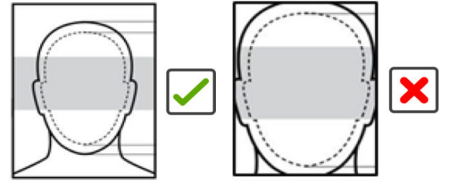  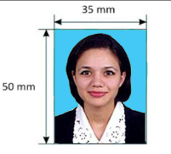
3 | Copy of the Highest Educational Certificate | - Certificates that are not in Bahasa Malaysia (Malay) or English, must be translated to English and attested by the respective countries mission Malaysia OR the Malaysian mission in the country the certificate was issued.  - Certificates issued in North Korea & the Peoples Republic of China (PRC) compulsory to be attested by the Malaysian mission in its country of origin OR the respective countries mission in Malaysia.  - The original / hard copy of the attested certificates are required for the following nationalities (If previously not submitted to MDEC) :  - Colombia  - Bangladesh  - Pakistan  - China (PRC)  - Iran  - North Korea  - Afghanistan
4 | A Detailed Resume / CV | - Consist basic information such as personal details, educational history and professional qualifications.  - Compulsory to state the total number of year's working experience which include current and past work experience, including full name of the employer, the duration of employment, job titles and job scope.
5 | Comprehensive Job Description | - To include location of the position, reporting line and list of task/responsibilities for the position applied.

IMPORTANT NOTES :

- Documents provided must be in clear and Color copy
- Additional documents may be required if requested by the MDEC upon their verification stage

